Chapter 3 HW Problems

Problem 3.1

What is the moment the force shown below exerts about…

1. Point A?
2. Point B?

(Hint: Use Varginon’s Theorem)

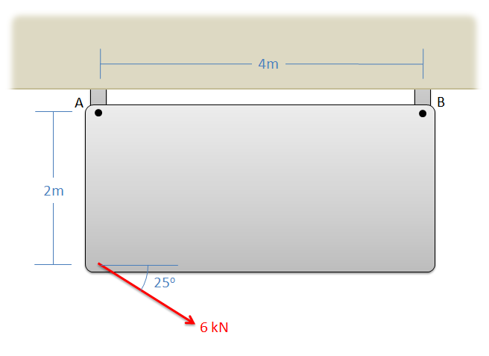

Solution: MA = 10.88 kNm, MB = 21.02 kNm

Problem 3.2

You exert a 50 lb force on the side of a fridge as shown below. Assuming the fridge is sitting on a rough surface and not moving, what is the magnitude of the moment exerted by the couple consisting of the pushing force and the friction force?

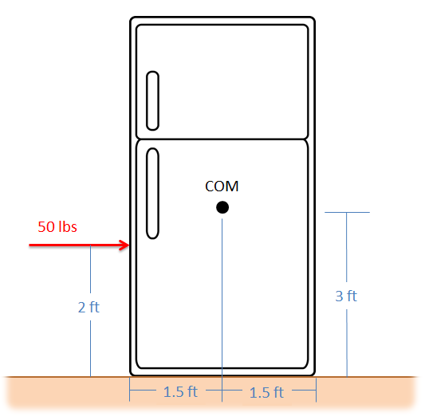

Solution: M = -100 ft lbs

Problem 3.3

What is the moment that the force shown in the diagram exerts about…

1. Point O?
2. The axis of the cylindrical shaft (the y axis)?

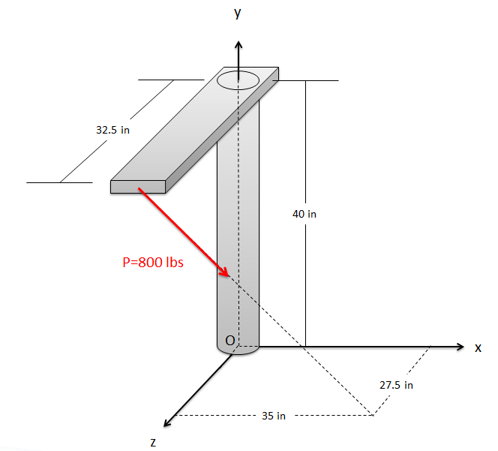

Solution: MO = [16484, 17046, -20979] in lbs, My = 17046 in lbs

Problem 3.4

The diving board shown below is supported by a pin joint at A and frictionless support at B. A 150 lb diver is standing at the end of the board. Determine the reaction forces acting on the diving board at points A and B.

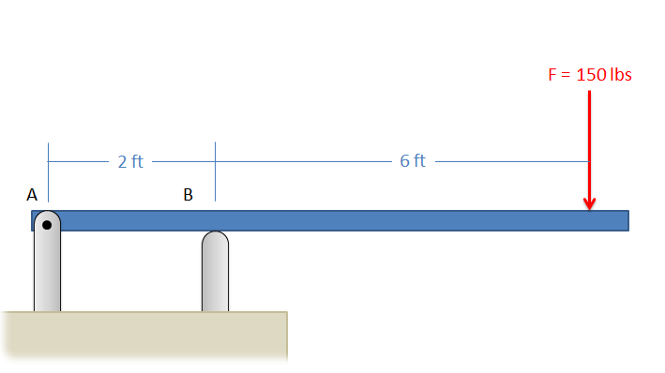

Solution: FAX = 0, FAY = -450 lbs, FBY = 600 lbs

Problem 3.5

A simplified crane is shown lifting a 400 kg load. The crane is supported by a pin joint at A, and a cable at B. Assuming the crane arm is in equilibrium, what are the reaction forces at A and the tension at B?

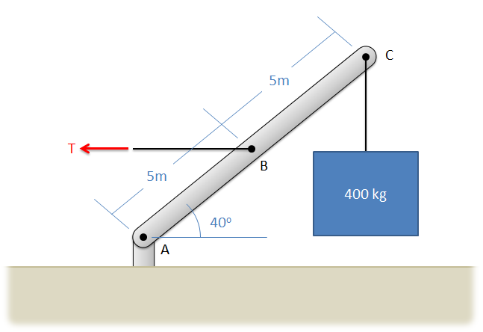

Solution: FAX = 9352.9 N, FAY = 3924 N, TB = 9352.9 N

Problem 3.6

A cart with a mass of 3500 kg sits on an inclined surface as shown below. Determine the reaction forces acting on each wheel of the cart as well as the tension in the cable supporting the cart.

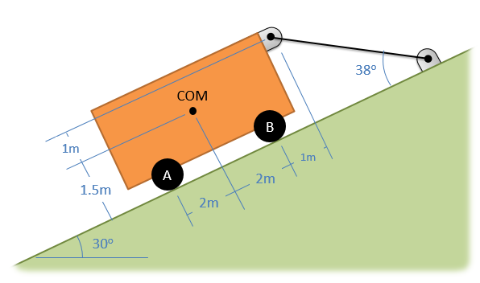

Solution: T = 21786 N, FA = 7222 N, FB = 35925 N

Problem 3.7

The lighting rig above a stage consists of two 100 lb uniform beams joined together in a T as shown below (assume the weight acts in the center of each beam). The rig is supported by three cables at A, B, and C. Determine the tension in each of the three cables.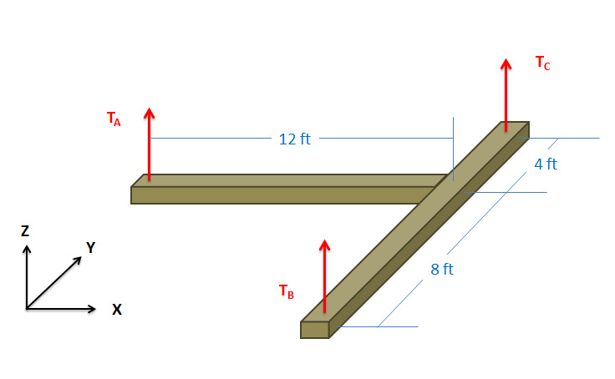

Solution: TA = 50 lbs, TB = 66.7 lbs, TC = 83.3 lbs